**Lesson Seventeen**

**Pre-requisite questions:** **1**

**Understand the basic mechanics** **2**

**The unit of weight is the Newton (N)** **3**

**Mechanics as they apply to levers** **4**

**Work done calculation** **5**

**Electrical science Power (mechanical)** **8**

**Practical** **9**

When I entered the classroom today. There were questions written on the whiteboard for my cohorts and I to answer.

# 

# Pre-requisite questions:

1. **What unit equates to P(rho) in R = PL / A?**

**Resistance in ohm per metre**

1. **Three resistors of equal value are connected in Parallel. If the R1 = 4Ω. What is the value of each resistor?**

**12 Ω**

1. **Two resistors of 5Ω are connected in parallel what is RT?**

**2.5Ω (⅕ + ⅕ = 1/rt )**

1. **Two resistors of 5Ω are connected in series what is RT?**

**10Ω**

1. **Calculate the power in a car headlight if the supply is 12 V & has a current of 4.58A**

**54.96 watts**

1. **Two resistors of 10Ω are connected in parallel calculate the RT?**

**RT = 5**

1. **Three resistors of 10,20,25Ω are connected in series, if the current is 4A calculate the circuit voltage?**

**240V**

1. **What formula would you use to calculate the area of a triangle?**

**½ base X height OR (base X height) / 2**

1. **A total of 24 consumer units are impacted from storage, 18 are found to be complete. How many are incomplete? What percentage are still in good condition?**

**6, 75%**

1. **A triangle has a base of 4cm and a height of 5cm calculate the area?**

**(4 X 5) / 2**

# 

# Understand the basic mechanics

**Mass** = never changes stays the same.

**Weight** = Changes due to the impact of gravity. Person A would have a different weight if he was on earth compared to on the moon.

Symbol of mass is m

Mass is measured by determining the extent to which a particle or object resists a change in its direction or speed when force is applied.

**W** = **m** x **g** => **W**eight = **M**ass x **g**ravity.

**9.81 metres per second2**  = is the force of gravity.

F = m x a => Force = Mass X Acceleration

The gravity is in an object even if it is stationary. Therefore, the gravity becomes the object’s weight.

**Question**

A distribution board sits on a bench 1.5m from the floor, and has a mass of 80 kg. Calculate its weight using gravity at 9.81 m/s2?

**Working out**

W = m X g

80 X 9.91 = 784.8 N

# The unit of weight is the Newton (N)

**Question**

Weight = Mass X gravity

If the gravitational pull on Earth g = 9.81 m/s2. What is the weight of a mass of 2kg?

**Working out:**

2 x 9.81 = 19.62 N

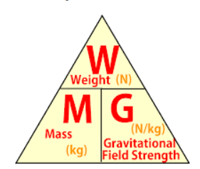

In a stationary object the weight is the **Mass** X **Gravity**.

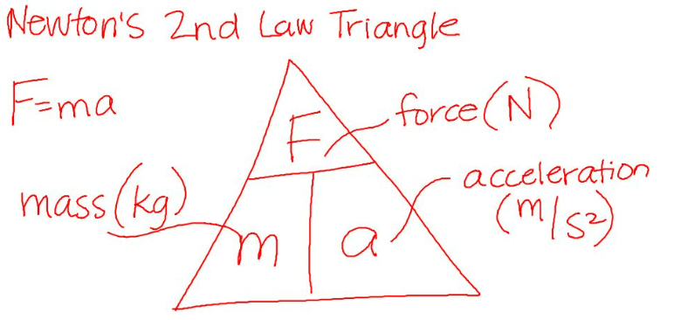

However, if you drop a pen it becomes F (Force). Therefore, the formula is **Mass** X **Acceleration**.

**Force** involves two quantities, the **mass** (**m**) and **acceleration** (**a**) or the rate at which it moves.

# Mechanics as they apply to levers

A lever lets us use a small force to apply a large force to an object.

There are three classes. The fulcrum is the point where pressure is applied.

**Class 1** - Fulcrum is in the middle between the load and force. For example a seesaw.

**Class 2** - The load is in the middle, between the fulcrum and the force. Pushing a wheelbarrow is an example.

**Class 3** - The force is in the middle between the fulcrum and the load. A man doing bicep curls as an example.

Gears are wheels with teeth, the gears fit into one another to power other cogs.

An incline plane is a ramp.

A pulley. An example, is a garage where the mechanic uses a chain to move an engine engine into a car.

Two types of pulley: a fixed pulley or a moveable pulley.

**Question**:

An object has a mass of 6kg and is to be accelerated at 6 m/s2. aWhat force is required to achieve this?

**Working out:**

F = m xa

F = 6x6

F = 36 newtons (N)



**Question:**

A force of **10 N** is applied to an object with a mass of **2kg**. What will its acceleration be?

**Working out:**



**F / M = A**

10 N / 2kg = 5 m/s2

# Work done calculation

Work done is measured in Joules (J).

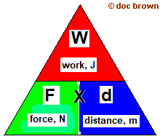

Force (N)

Distance(M,Metres)

Work = Force X Distance

**Question**

A car has to be pushed started, it has a mass of 1,000 kg and it is pushed 10 m before it starts. What is the work done?



1. As the equation states it is **W = F X D**. We have to find the **Force** in the equation.

**Force** = mass x gravity

**Force** = 1,000 kg X 9.81

**Force** = 9810 N

1. W = F X D

Work done = **Force** X Distance

Work done = 9810 X 10

Work done = 98100 Joules (J)

**Question**

A distribution board has a mass of 50 kg. How much work is done when it is moved 10 metres?

**Working out:**



W = **F** X D

Work done = **Force** X Distance

**Force** = m x g (50 X 9.81) - we do this step first in order to get the weight, because mass x gravity equates to the weight.

**Force** = 490.5

Work Done = **Force** X Distance

Work Done = **490.5** X 10

Work Done = 4905 Joules.

**Question**

The work done to move a consumer unit is 800 J and required a force of 20N, what distance was it moved?

**Work done** = **Force** X **Distance**

**800 J** = **20 N** X **40 metres**

# 

# Electrical science Power (mechanical)

Power is the rate at doing work.

**Power(P)** = **Work done (Joules)** / **Time taken to complete work (seconds)**

Work also = Force X Distance

Energy or work is measured in Joules (T).

Power is measured in J/S also known as Watts (W) joules per second.

**Question**

A Distribution board has a mass of 50 kg and is moved 10 M. Calculate the work done?

**Work Done** = **Force** X **Distance**

**Work Done** = **(Mass X Gravity)** X **Distance**

**Work Done = (50 X 9.81) X Distance**

**Follow-up**

If it took **20 seconds** to move the distribution board how much power was used ?

**Transpose for P Power(P) = Work done (Joules) / Time taken to complete work (seconds)**

**P = 4905 / 20**

**P = 245.25 Watts**

**Question**

**If a mass of 500 kg is lifted through a height of 2 m, calculate the work done?**



* **Work Done = Force X Distance**
* **Work Done = (Mass X Gravity) X Distance**
* **9.810 = (500 X 9.81) x 2**
* **9.810 = 4.905 x 2**
* **9.810 Nm, Joules**

# 

# 

# 

# Practical

* We had trunking that was 750 mm in length. 400 mm on the X axis, 350 mm on the Y axis.
* Mark where the bend will be
* 50 mm one side, 50 mm the other side (depends on the trunking size. If it is 50 then your mark is 50 on both sides. If it is 30 then mark 30 on both sides.)
* Cut down the line
* Then file the outside part
* Then tweak off